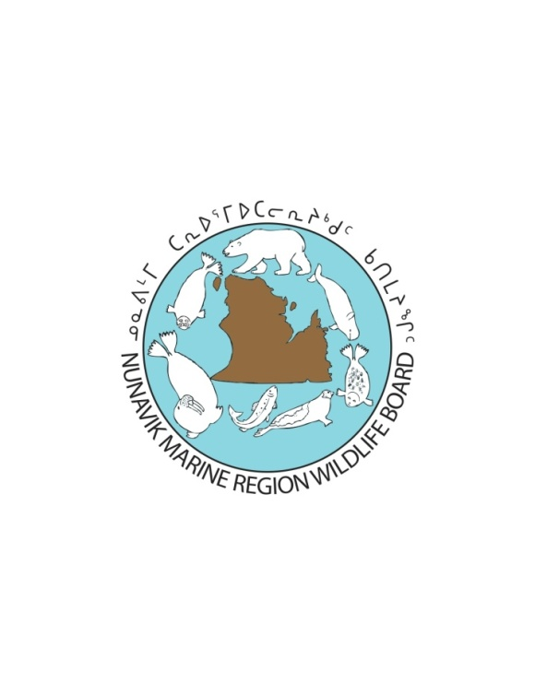

**Research Proposal Form 2017**

**(Funding Request)**

**Submission deadline for funding: February 15th, 2017**

|  |
| --- |
| **For Internal Office Use Only** |
| Date received:  Project file number: |

|  |  |
| --- | --- |
| **General Information About the Applicant** | |
| Name of organization / department | Name of project leader or contact person |
| Mailing address | Mailing address of contact person (if different) |
| Organization/Researcher website | Telephone |
| Email | Facsimile |

|  |  |  |  |  |
| --- | --- | --- | --- | --- |
| **Project Description – General Information** | | | | |
| Title of project | | | | |
| Keywords to describe project (list up to 10 keywords; separated by commas) | | | | |
| Research type  Survey Behavioural Sampling Other: | | | | |
| New application  Resubmission | | Date of original submission:  Date of resubmission: | | |
| Project information (Access)  Authorization to access to NMR required | | Project information  Project funded by NMRWB in a previous year  Report of previous field season submitted | | |
| Project duration  From: To: | | | | |
| Total Amount Requested from NMRWB: | | | | |
| General location of project (i.e. communities visited, islands used, etc.) | | | | |
| **Project Description – Executive Summary**  This summary will be shared with board members as they consider whether to approve funding and/or access to the Nunavik Marine Region, and will be made public if the project is approved; language should be adapted accordingly. This summary should include background information about the project and a description of the main research objectives, hypotheses and the methods to be used. | | |
|  | | |
| **Project Description – Executive Summary (Inuttitut)**  It is recommended that an Inuttitut version of the executive summary be included in all research proposals. However, this will be mandatory only for projects that have been approved for funding. | | |
|  | | |
| **Project Description – Methodology**  Provide a detailed explanation of the methods used to complete the field-portion of this study and the timeframe for completing them. Pay particular attention to any steps that involve the capture and/or of wildlife. Procedures that require external approval (e.g. Animal health protocols) should also be described in detail, and the status of such approvals given. Describe anticipated or potential disturbances to endangered species or species at risk. Include potential impacts on habitats used by the species, nature of harm, and the likelihood of harm or encounters. You should also explain how this project will involve local Inuit and integrate *Inuit Qaujimajatuqangit*. If possible, include a map of the study area with all temporary installations (campsite or other) and other sites of interest (i.e. flight lines, fuel caches, trap sites, etc.) clearly identified. Please indicate the number of people participating in the field work (including Inuit guides or technicians) and their roles. | | | |
|  | | | |
| **Project Description – Outcomes**  Describe how this project will contribute to wildlife management in the Nunavik Marine Region and why it is a priority for this region. You should also provide a brief timeframe for availability of results and describe the type of information that will be returned to the NMRWB. List publications expected to result from this study. | | | |
|  | | | |
| **Project Description – Communication Plan**  Describe the steps that you will take to ensure that Nunavik Inuit are informed about this project and their involvement in it. Indicate how you intend to consult and communicate with the communities involved prior to and during research; have any discussions begun? You should also describe how any results will be distributed to communities upon completion of the study and show how the planned research will benefit Nunavik Inuit, at the local or regional level. | | | |
|  | | | |
| **Project Budget and NMRWB Contribution**  Provide a detailed budget of expenditures that will be incurred during this project. Contributions (including in-kind support) from organizations other than NMRWB should be listed. Budget categories should include the following (additional categories can be used):   1. Salaries and Benefits including those provided to local Inuit (e.g. for field assistance or honouraria for interviews) 2. Materials and Supplies (only project-specific funding should be requested from the NMRWB) 3. Travel Costs 4. Community Consultations and Reporting 5. Miscellaneous Costs (provide some description of these)   Research budgets should be appended to the research proposal (for electronic submissions, budgets can be attached as Microsoft Excel spreadsheets). | | | |
|  | | | |